Configure Secret Management Solution

Overview

Secret management is a critical practice in modern software development that ensures sensitive information, such as API keys, tokens, and passwords, is handled securely. This documentation demonstrates how to configure and test secret management in GitHub by using repository secrets and GitHub Actions. By following this guide, teams can securely inject secrets into their applications without exposing them in source code, maintaining both operational security and compliance standards.

Prerequisites

- A GitHub repository with writes access.
- Basic knowledge of Node.js (JavaScript runtime) and ability to run scripts.
- Familiarity with GitHub Actions workflows and YAML configuration.
- Access to a valid API key or test key (for demonstration purposes).
- Understanding of environment variables and their role in securing application secrets.

Step 1: Create a Simple Application to Test With

- Click on New.

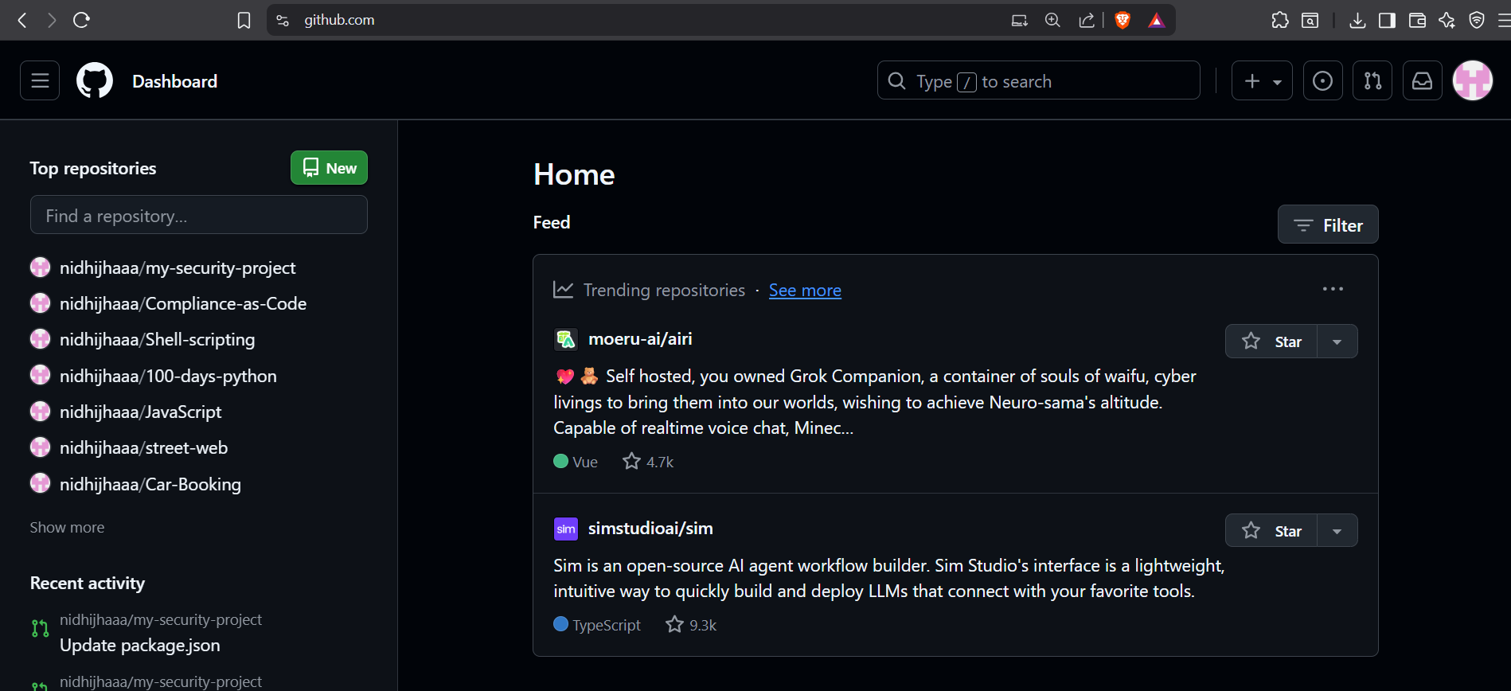

- Write repository name Click “Create repository”

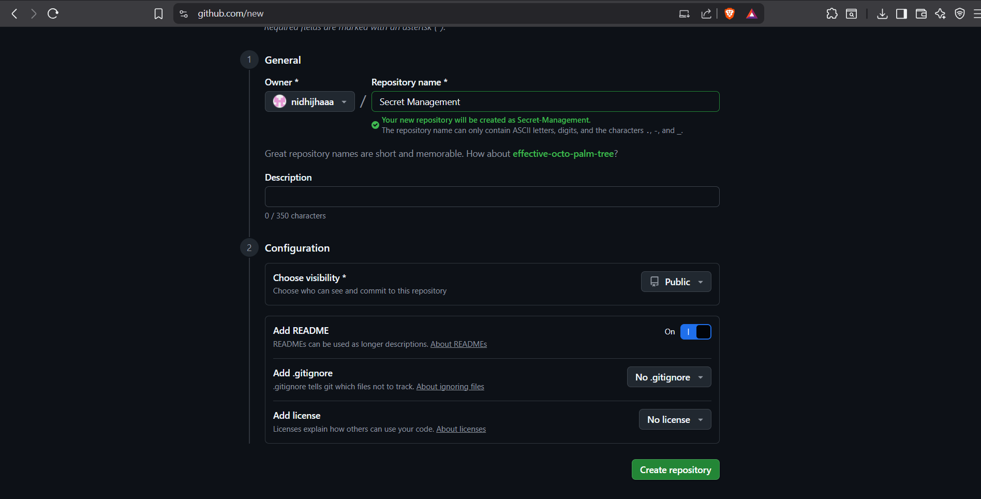

- Click the Add file button and select Create new file

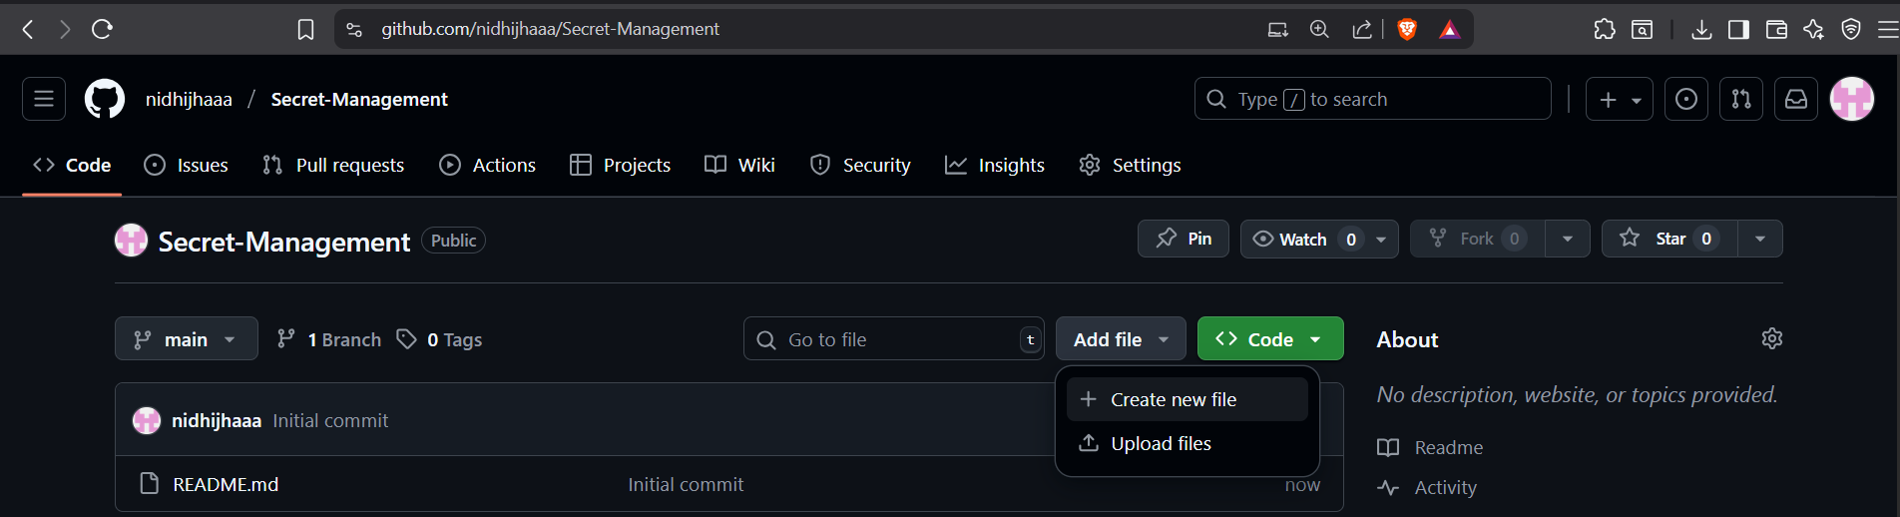

- Name the file app.js.
- Copy and paste the following code into the file:

// app.js - A simple script that uses a secret API key

// This line looks for a secret in the environment variable called PRODUCTION_API_KEY
// If it doesn't find it, it will use a default empty string (for local testing)
const apiKey = process.env.PRODUCTION_API_KEY || '';

if (apiKey) {
console.log("Success! The application has loaded the API key.");
console.log("The key is: " + apiKey);
// In a real app, you would now use this key to connect to a service.
} else {
console.log("Error: The PRODUCTION_API_KEY was not found.");
console.log("Hint: Make sure it's set in GitHub Secrets!");
}
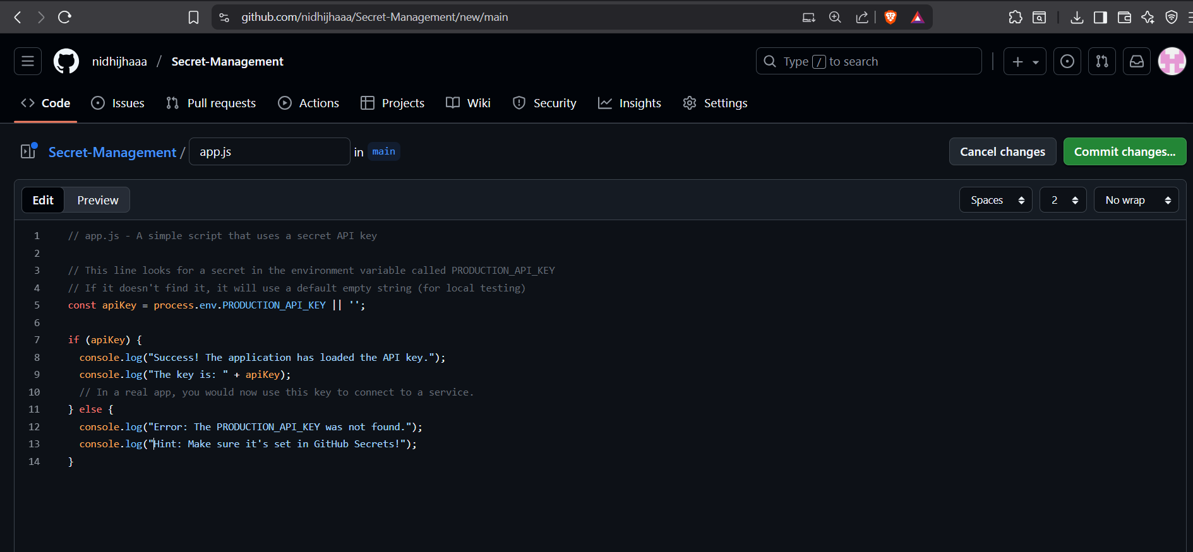

- Type a commit message: Add simple app.js script for secret testing.
- Choose Commit directly to the main branch.
- Click “Commit changes”.

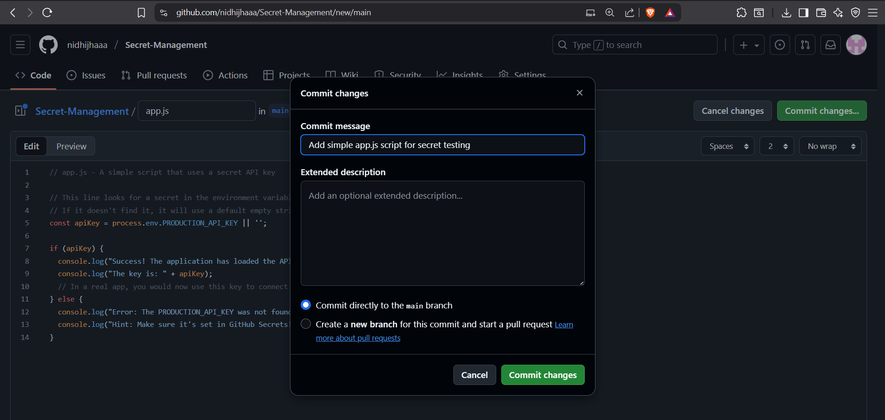

What this code does: It tries to load a secret named PRODUCTION_API_KEY from its environment. This is the secure way to handle secrets.

Step 2: Store Your Secret in the GitHub Vault

- From your repository's main page, click on the Settings tab.

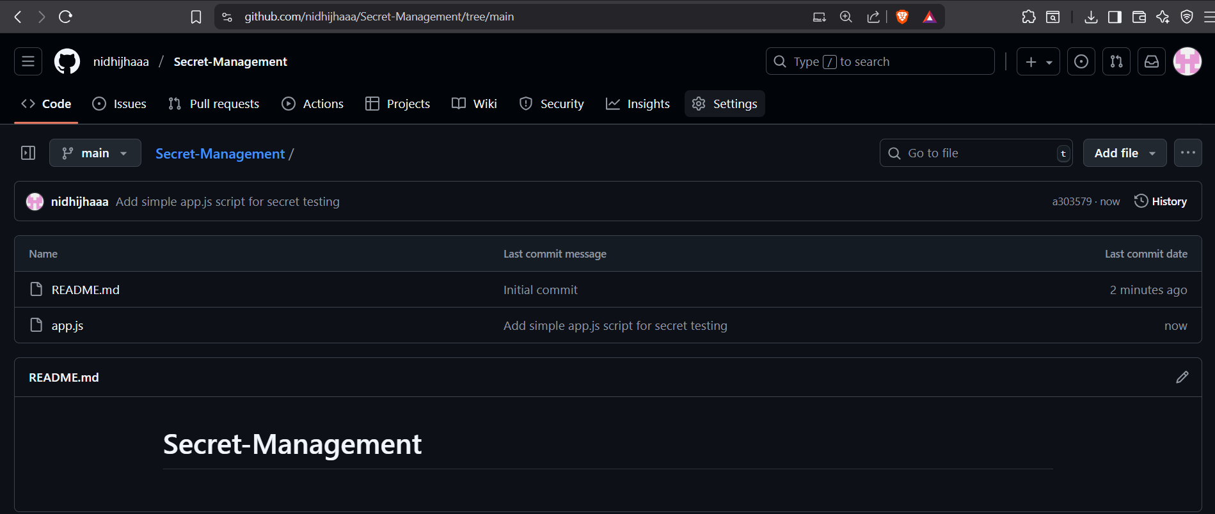

- In the left sidebar, click on Secrets and variables and then select Actions.

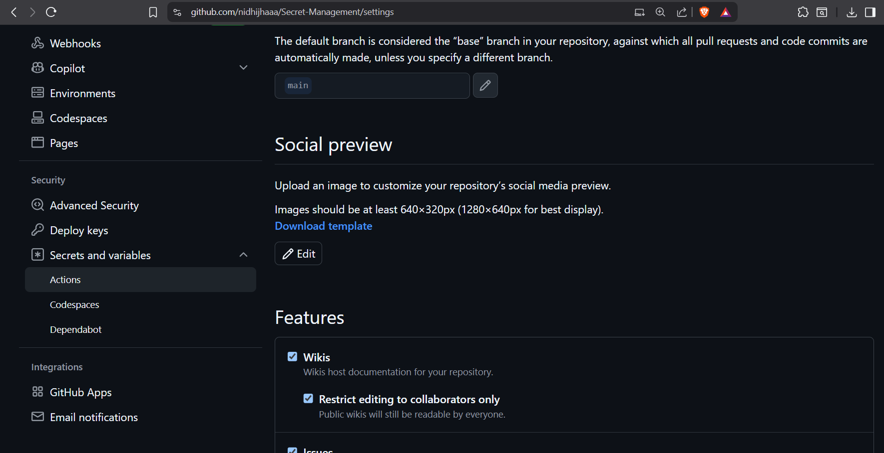

- You are now in the secrets management page. Click the green button New repository secret
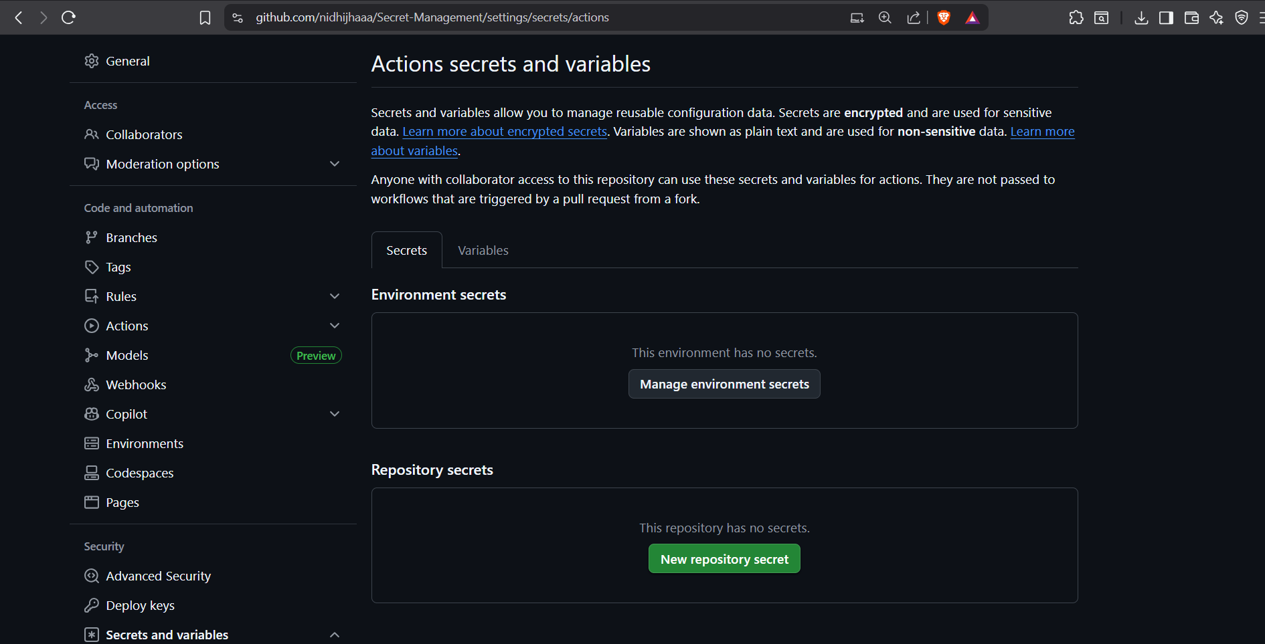

- Fill out the form:
  - Name: PRODUCTION_API_KEY
    - This name MUST exactly match what your code is looking for: process.env.PRODUCTION_API_KEY.
  - Value: fake-secret-key-1234567890abcdef
    - For this test, we are using a fake key. In a real project, this would be a real, sensitive key from a service you use.
- Click the green Add secret button

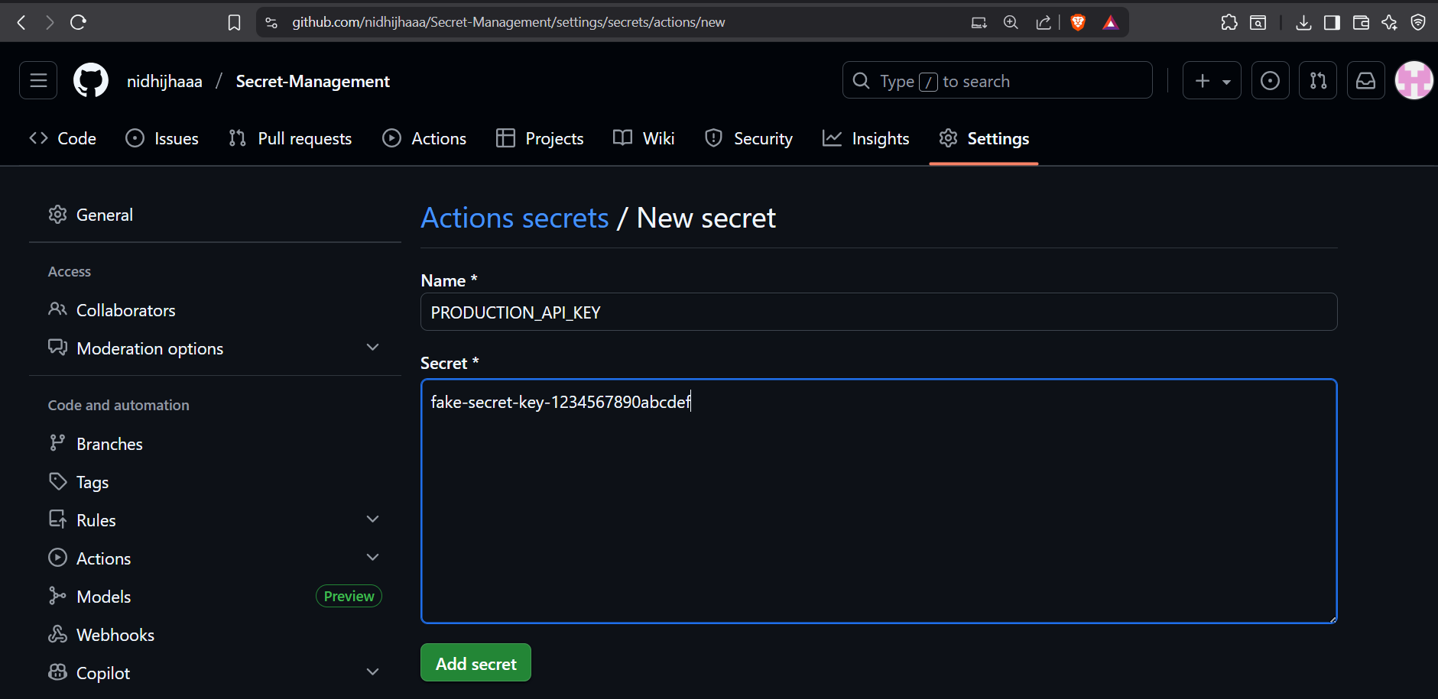

Step 3: Create a Workflow to Use the Secret

We will now create an automated task (a "workflow") that runs our app.js script and safely gives it the secret.

- Go back to your repository's main page (click the Code tab).
- Click Add file -> Create new file

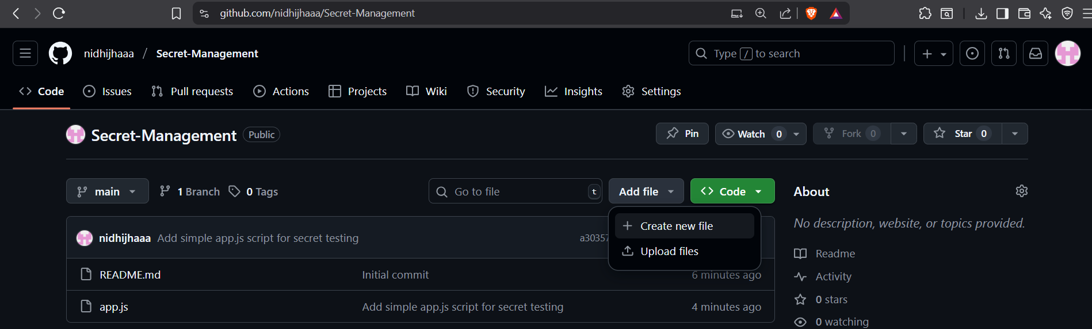

- This is very important: In the filename box, type exactly: .github/workflows/test-secret.yml
The .github and workflows folders are special. This is where GitHub looks for automation instructions.

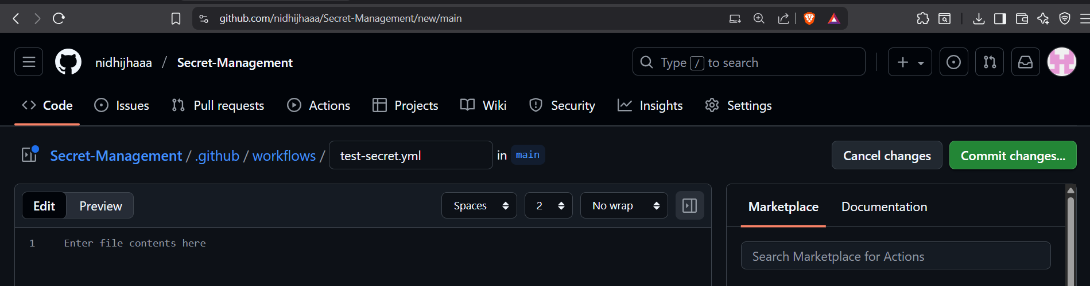

- Copy and paste the entire YAML code below into the new file:

name: Test Secret Management

# This workflow will run every time you push code to the main branch
on:
push:
branches: [ "main" ]

# The jobs (tasks) that will run
jobs:
# A single job named "test-secret"
test-secret:
# This job will run on a fresh Ubuntu Linux machine provided by GitHub
runs-on: ubuntu-latest

# The steps for this job
steps:
# Step 1: Checkout (download) the code from the repository
- name: Checkout code
uses: actions/checkout@v4

# Step 2: Set up Node.js to run our app.js file
- name: Setup Node.js
uses: actions/setup-node@v3
with:
node-version: '18' # Version of Node.js to use

# Step 3: Run the application script with the secret
- name: Run app with secret
run: node app.js # This command executes our app.js file
env:
# This is the most important line.
# It takes the secret from the vault and makes it an environment variable.
PRODUCTION_API_KEY: ${{ secrets.PRODUCTION_API_KEY }}

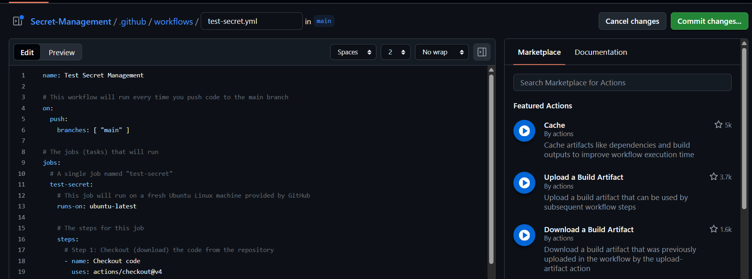
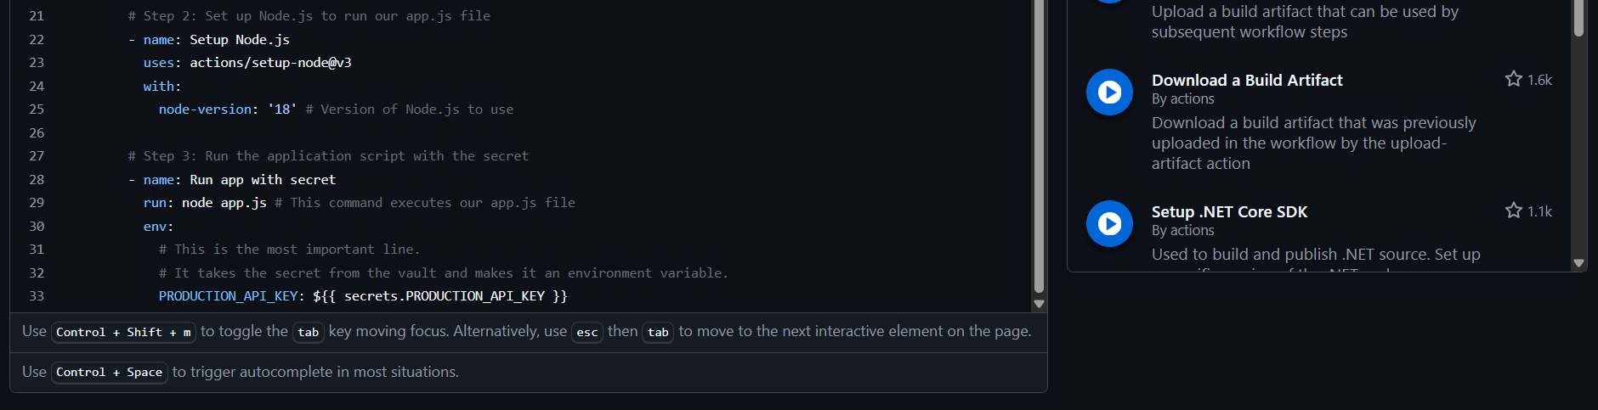

- Commit message: Add workflow to test secret management.
- Click Commit new file

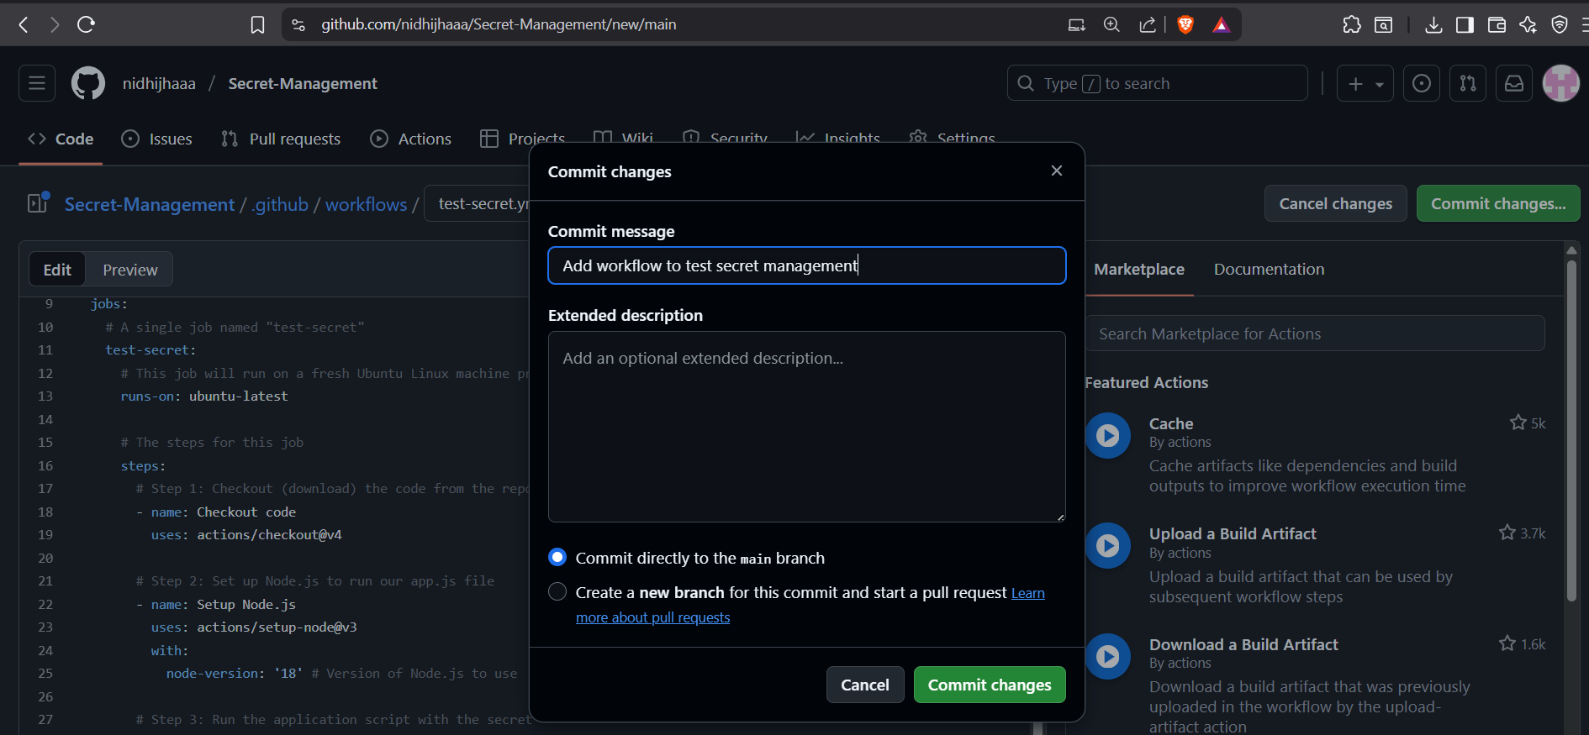

Step 4: Testing: See It in Action

- Go to your repository's main page.

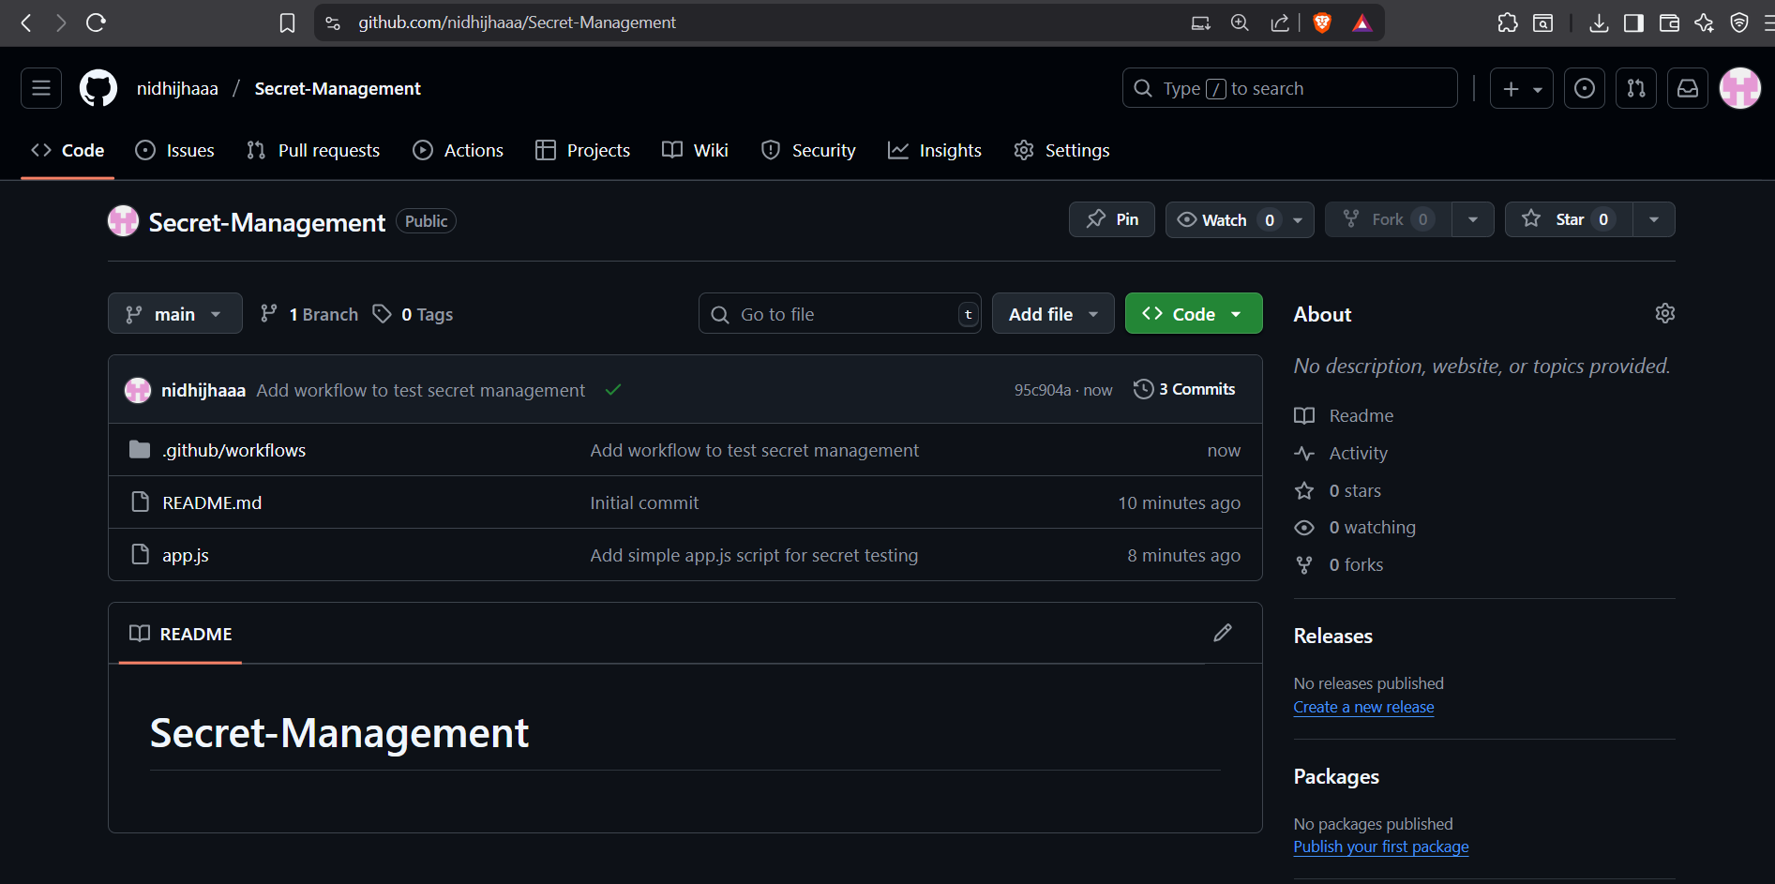

- Click on the Actions tab
- Click on the workflow.

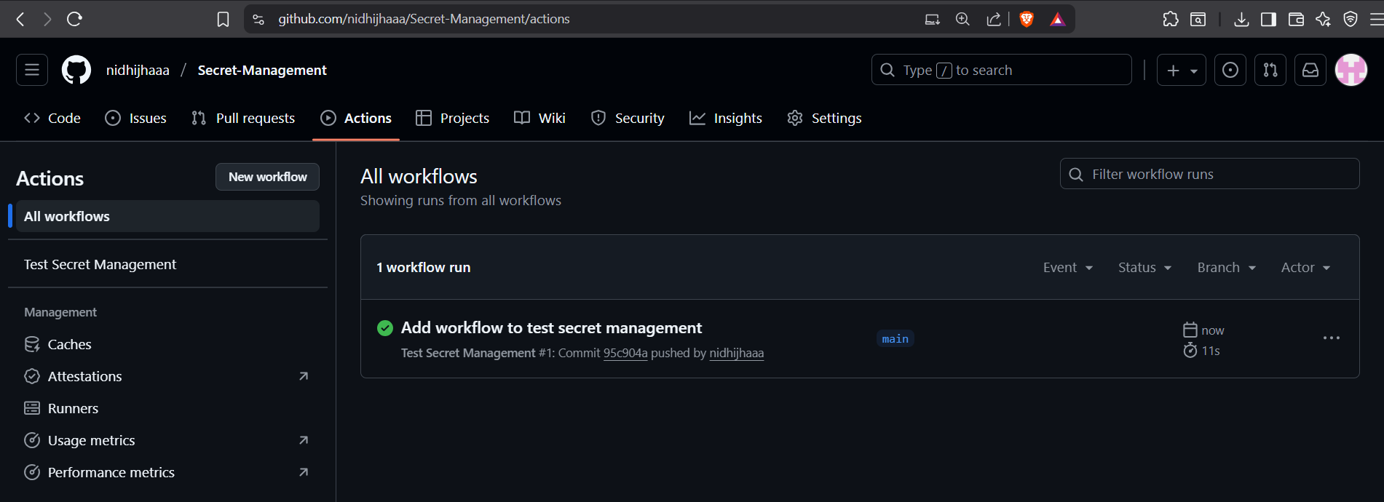

- Click on the job name test-secret
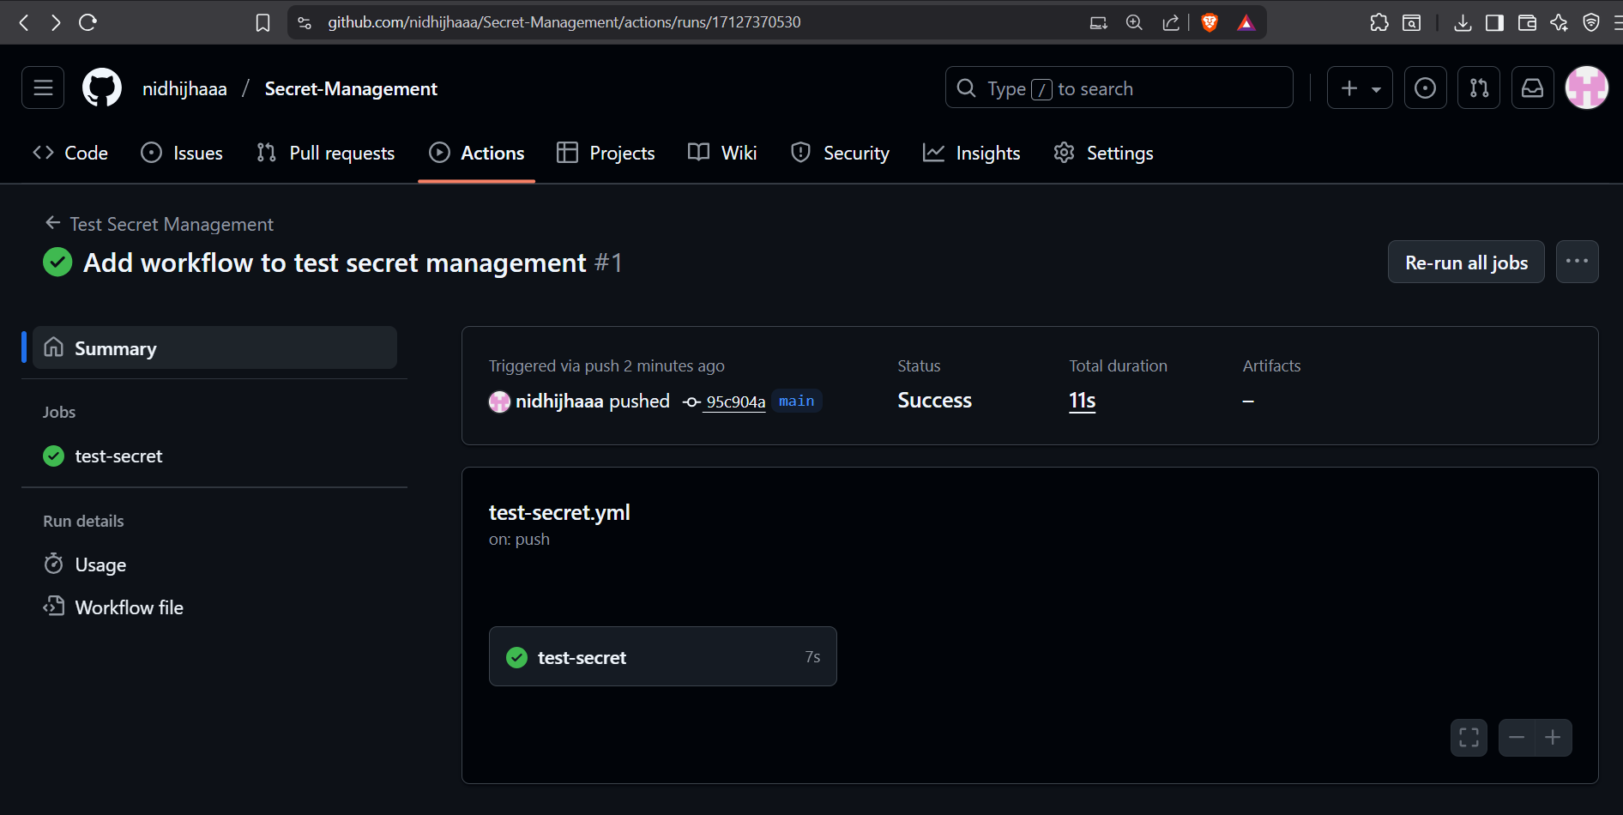

- You will see a list of steps. Click on the step Run app with secret to expand it and view the logs.

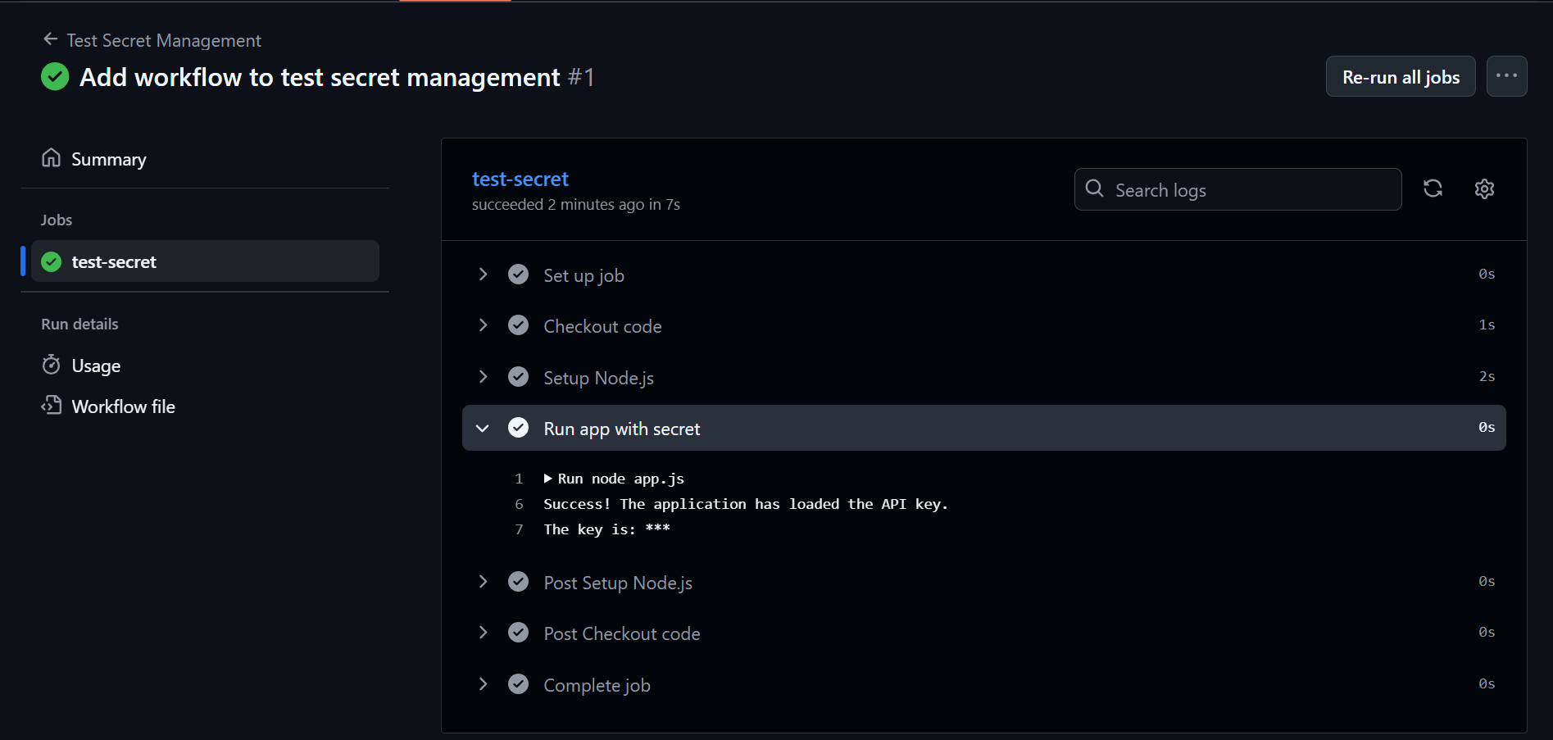

The workflow worked. Your app.js script successfully received the secret and used it. Most importantly, GitHub automatically masked the secret value in the log, replacing it with *** to prevent anyone from seeing it.

Conclusion

By configuring GitHub Secrets and integrating them with GitHub Actions, we establish a secure and automated method of managing sensitive information. This approach ensures that secrets remain encrypted, inaccessible in source code, and masked in logs, while still being available at runtime for application workflows.

This practice not only mitigates the risk of accidental secret exposure but also supports secure DevOps pipelines, regulatory compliance, and operational efficiency. Ultimately, implementing a secret management solution strengthens the overall security posture of software projects and lays a foundation for scaling secure development practices across teams and organizations.

